Project Title: A CRM Application for Laptop Rentals

# Project overview

This **CRM application** is designed to streamline and enhance the process of **renting laptops for short-term use**. The primary objective is to leverage Salesforce’s **Customer Relationship Management** capabilities to foster better customerrelationships, resulting in an elevated customer experience. By managing customer data, rental transactions,and inventory througha unified platform,this project optimizesstore operations, reducingmanual effort and improving overallefficiency. Additionally, the CRM facilitates seamless communication with customers via automated **email notifications**, keeping them informed about bookings, billing, and other important updates. The result is a comprehensive solutionthat supports **eﬃcient rentalmanagement, improved customersatisfaction**, and **operational excellence** for the business.

## Goals:

**Benifits:**

* Enhance customer satisfaction through personalized service.
* Streamline and automaterental booking and inventory management.
* Improve team productivity and reduce manualtasks.
* Provide data-driven insightsfor informed decision-makin
* Ensure secure and efficient data management acrossusers and roles.
* Centralizes customer data for personalized service and relationshipmanagement.
* Automates repetitive tasks to boost productivity and efficiency.
* Provides real-time insightswith customizable reportsand dashboards.
* Integrates easily with other tools, enhancing data flow and reducing silos.
* Offers mobile accessibility, enabling flexibility and responsiveness on the go.

# Objectives

* + **Streamline Sales Processes:** Use Salesforce solutions to automate and enhancesales workflows, minimizing manual tasks and boosting lead management efficiency.
  + **Improve Customer Engagement:** Take advantage of Salesforce tools to deliver a tailored experience for customers, enhancingcommunication and overallsatisfaction.
  + **Insights from Data:** Utilize Salesforce analytics to collectactionable insights and effectively monitorperformance metrics.

# Salesforces key features and concepts utilized

This Salesforce CRM project utilize the following concepts and incorporates a variety offeatures

* + **Custom Objects:**Defined unique custom objects such as **Consumer**, **Laptop Bookings**, **Total Laptops, Billing Process** to handle specific requirements for managing customerdata, rental transactions, and inventory. These custom objectsallowed precise data handling and organization beyond standard Salesforce objects.
  + **Custom Tabs:** Created custom tabs for each custom object to provide easy access to the **Consumer**, **Laptop Bookings**, **Billing Process** and **Total Laptops** information, enabling the team to navigate and manage data directly from the Salesforce app interface.
  + **Creating Lightning Apps:** Built custom Lightning apps for the **Laptop Rentals CRM** to provide a tailored user interface, streamline workflows, and improve user experience by organizing all necessary tabs, reports, and dashboards under one cohesiveapplication.
  + **Validation Rules:** Implemented validation rules to maintain data integrity and enforcebusiness requirements. For example, the customer should specify his/hercontact information eitherthe email or phone number.
  + **Profile Cloning and Custom Permissions:** Cloned the standard User profile to create **Owner** and **Agent** profiles, customizing permissions to restrict or allow

access to specific objects and data fields based on user roles. This ensured proper accesscontrol and safeguarded sensitive information.

* + **Role Hierarchy and Role Creation:** Established a role hierarchy by creating an

**Owner** role under the CEO and an **Agent** role underthe Owner.

* + **User Creation:** Created two user accounts: **Owner** and **Agent**. The Owner has elevated permissions for full control,while the Agent can handle customer interactions and manage bookingswithin the limitsset by their profile.
  + **Flows for Laptop Models:** Created a Record Triggered for Laptop Models and for autmating the model selection,processor type selection, selecting the numberof months to rent the laptop and the chargesbased on the chosen inputs.
  + **Apex Programming:** Created Apex classes and triggers to carry out complex businesslogics and triggerthe email notifications after booking a laptop for rent.
  + **Reports and Report Sharing:** Created a custom report to provide insights into rental activity, and filtered the data accordingto the **types of versions** shared this report to the Owner.
  + **Dashboard Folder and Dashboard Creation:** Created a Dashboard to represnt the created report in the form of a donut chart that enables to analyse the rental amounts for each version.

# Detailed steps to Solution Design:

The a step-by-step outlinefor the **Solution Design**of the **Laptop RentalsCRM**

## Step 1: Creating objects and required fileds

Created objects such as cosumer, Laptop Bookings, Total Laptops, Billing Process and created the required filed and relationships for each of the objects.

* + **Consumer Object:** The Consumer object is designed to store and track customer information within the Laptop Rentals CRM system. It provides a centralized repository of customer details,allowing quick access to key information for eachrentaltransaction.

## Fields and Relationships created:

**Phone_number__c:** Stores the contact number of the customer for easy communication.

**Email__c:**Records the customer’s email address for notifications and follow-ups. **Address__c:** Holdsthe customer’s physicaladdress for deliveryor identification purpose.

**consumer_Status__c:** Indicates the currentstatus of the customer (e.g., student,employeeor others) for tracking engagement.

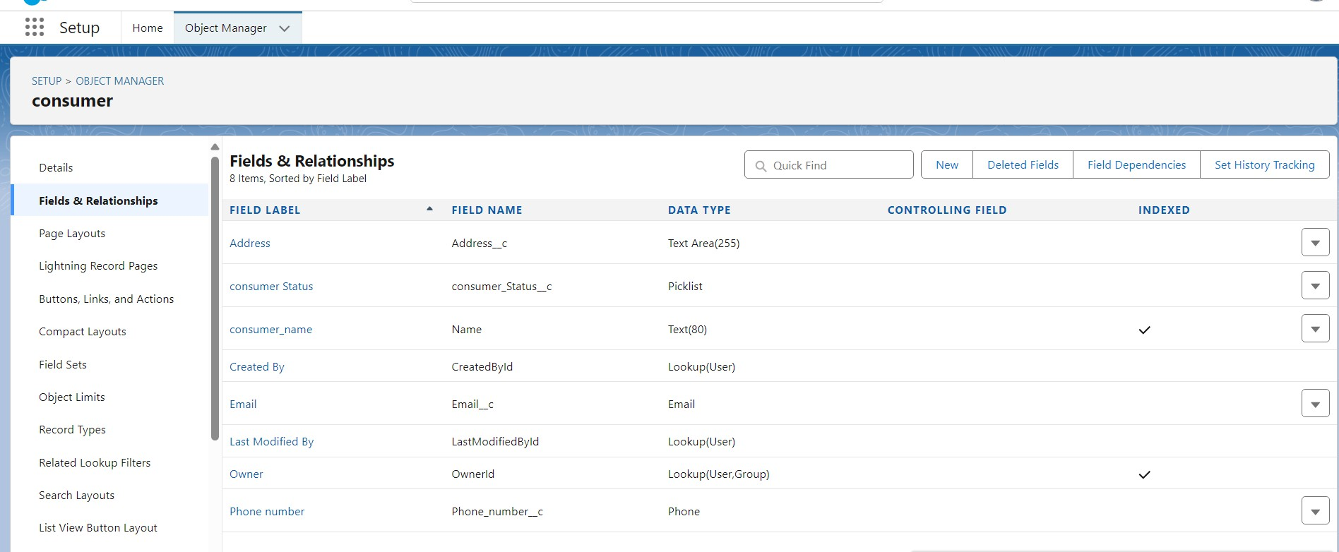

* **Laptop Bookings Object:** The Laptop Bookings custom object is used to store and manage information about each rental booking made by customers. It links to the Consumerobject to associatebookings with specific customers and connects with the Total Laptops objectto track inventory.

## Fields and Relationships created:

**Name:** A text data the stores the booking name for each booking

**Laptop_names__c:** A picklistvalue that enablesthe cosumers to select the laptopmodel to be selected.

**core_type__c:** A picklist valueto specify the processor type for the laptop modelsthat has been selected by the consumers.

**Amount__c:** Amount the consumer wants to pay for the selected laptopmodel.

**Email__c:** Stores the email of the customers.

**Name__c:** A lookupvalue to the consumer object that specifieswhich consumeris going to rent the laptop.

**Total_No_Of_Laptops__c:** A lookup valueto the Total Laptops objectthat species the number of laptops the consumer wants to rent.

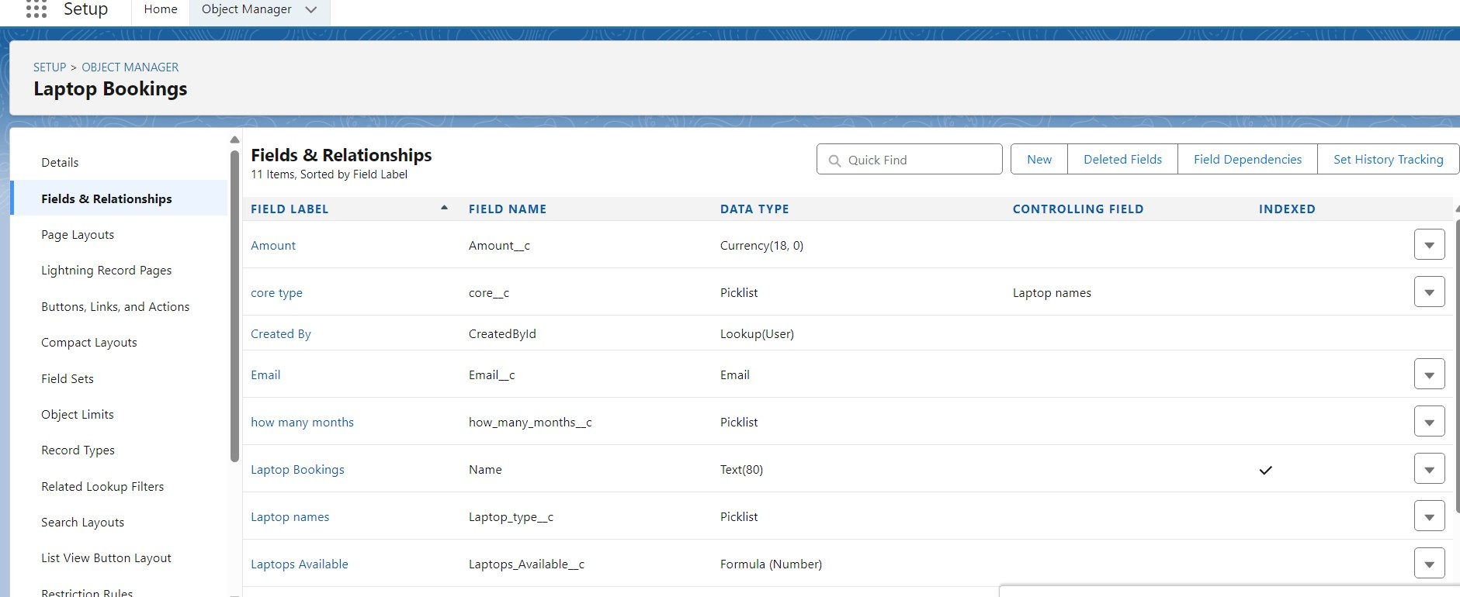

* **Total Laptops Object:** This custom object maintains an inventory of all available laptops for rental. It tracks details like the specifications of each laptop, its availability status, and usage history.

**Fields and Relationships:**

**Laptops_Available__c:** Keeps track of the number of laptops availablein the inventory. This is a formula field in which the value will be updated when laptopsare to be shippedfrom the inventory.

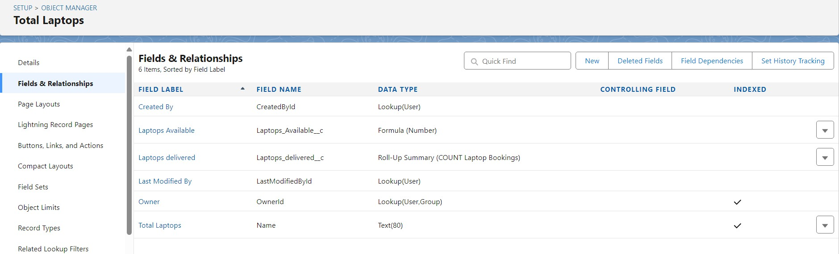

* **Billing Process Object:** This custom object manages the billing process for laptop rentals. It tracks billing details, payment status, and related transactions to ensure accurate financial records for each rental.

**Fields and Relationships**

* + **Amount__c**: A formula field (Number) that calculates the total amount for the billing process based on predefined criteria.
  + **Name**: The standard text field used as the unique identifier for each billing record.

This field’s label might be "Billing Process Name."

* + **Laptop_Booking__c**: A lookup field that associates each billing record with a specific laptop booking in the Laptop_Bookings c object.
  + **Name__c**: A master-detail relationship to the Consumer object, linking each billing record to a specific consumer.
  + 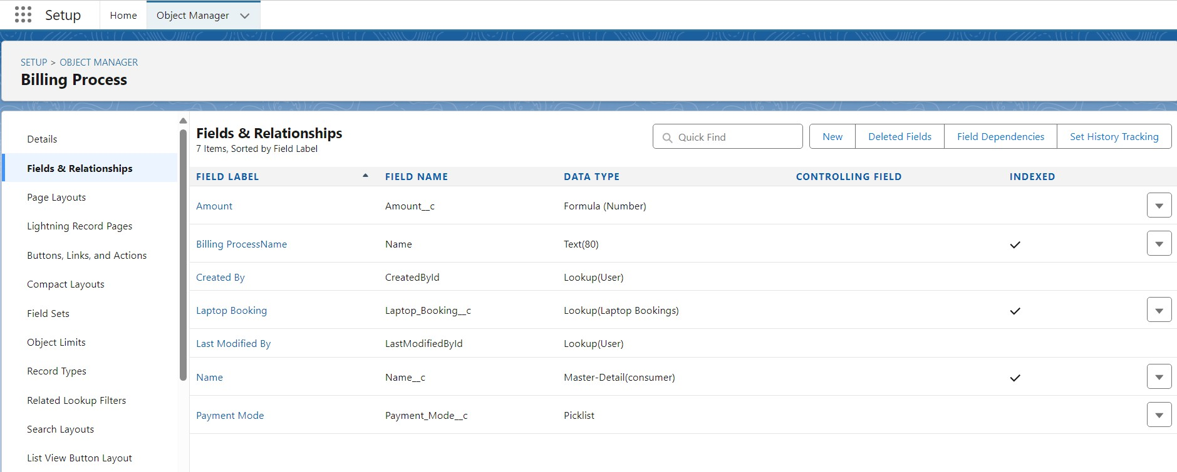**Payment_Mode__c**: A picklist field that specifies the mode of payment (e.g., "Credit Card," "Bank Transfer," "Cash").

## Step 2: Creating Tabs

The custom tab for **Total Laptops** was created to provide users easy access to the inventory management object, centralizing data on available laptops for rental.

* **Total Laptops Tab**: A custom tab for **Total Laptops** was created to provide users with easy access to the inventory management object, centralizing data on available laptops for rental.
* **Consumer Tab**: A custom tab for **Consumer** was created to manage customer details, enabling streamlined customer relationship management.
* **Laptop Booking Tab**: A custom tab for **Laptop Booking** was created to manage laptop rental transactions, linking each booking with specific customers and inventory.
* **Billing Process Tab**: A custom tab for **Billing Process** was created to handle billing and payment details, tracking all financial transactions related to laptop rentals.

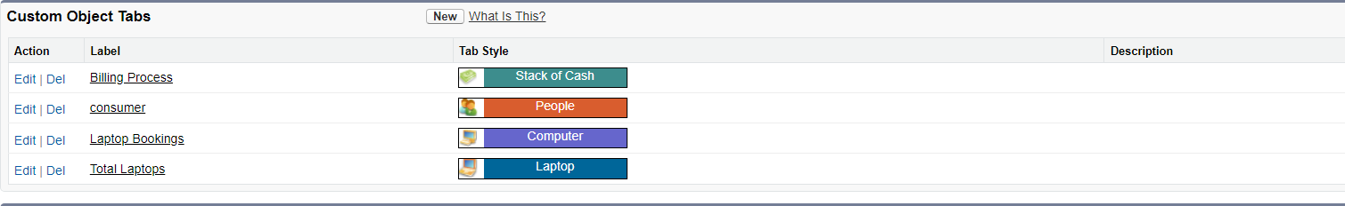

## Step 3: Creating a Lightning App

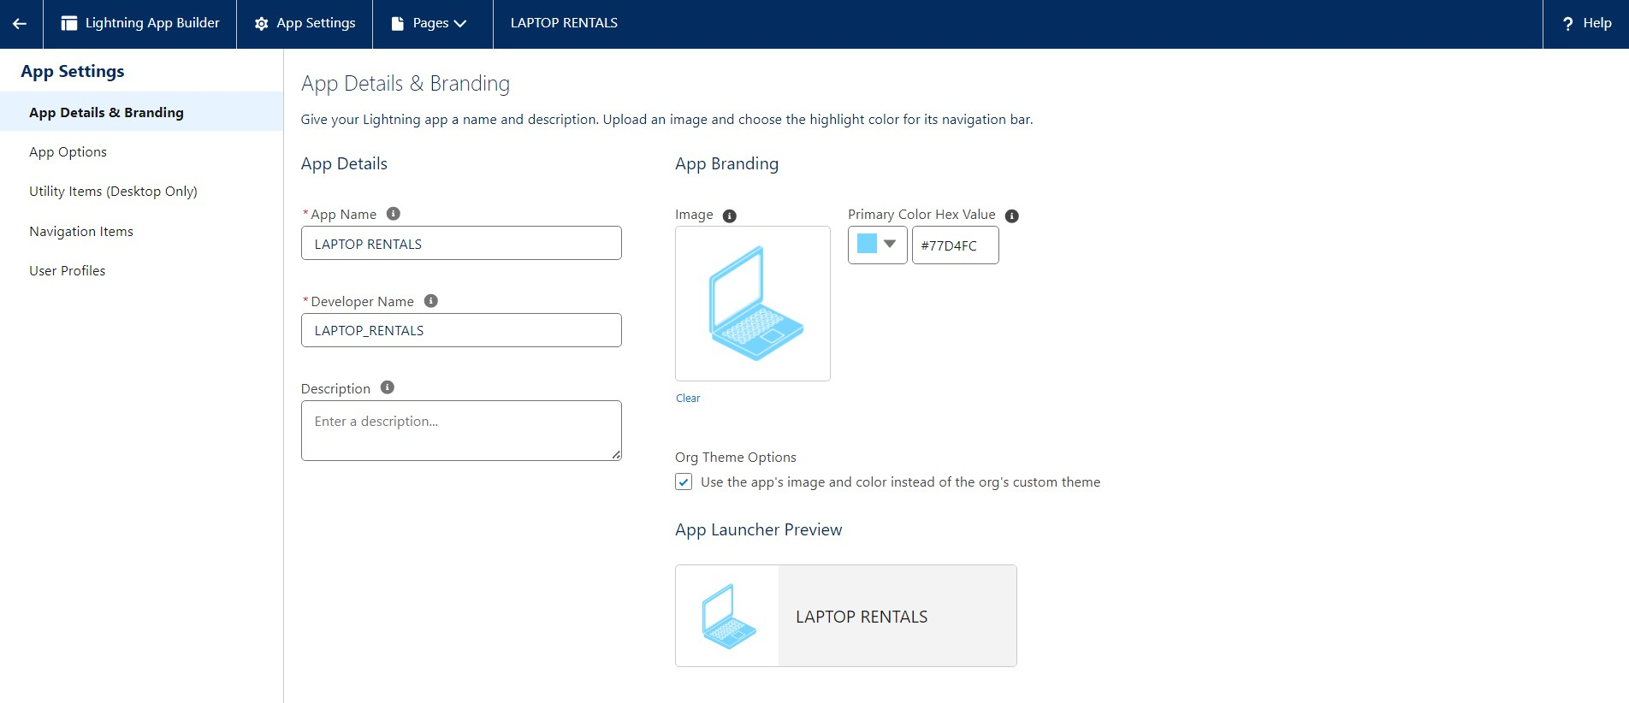A new **Lightning App** called **LAPTOP RENTALS** was created to centralize and streamline the entire laptop rental management process within Salesforce. This app serves as a dedicated platform for managing customer data, processing laptop rental bookings, monitoring inventory, and handling billing activities, all in one place.

**Step 4: Creating the Validation Rule for Phone Number Field in Consumer Object**

**Phonenumberoremailblankrule**: A validation rule called **Phonenumberoremailblankrule** was created in the **Consumer** object to ensure that both phone number and email fields are not left blank. This rule enforces that either the **Phone Number** or **Email** field must be populated for each consumer record.

**Validation Rule Details**:

* **Rule Name**: Phonenumberoremailblankrule
* **Description**: "Phone number and email should not be blank."
* **Formula**: OR(ISBLANK(phone_number c), ISBLANK(email c))

This validation rule improves data integrity by requiring at least one contact method (phone or email) to be present on each consumer record, ensuring effective communication with customers.

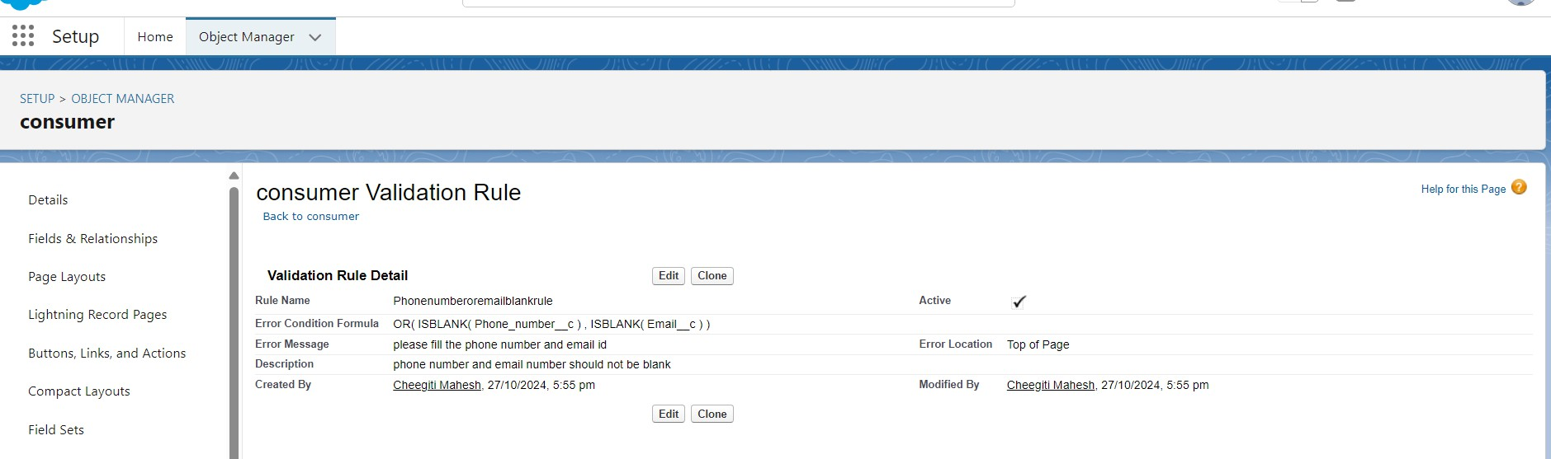

## Step 4: Cloned the Profiles

Cloned the the Standard User to Owner and Agent Profiles and given Custom Object Permissions to each of the Roles. And then created two users with Owner and Agent Role after creatingthese Roles Heirarchy.

**Owner:**

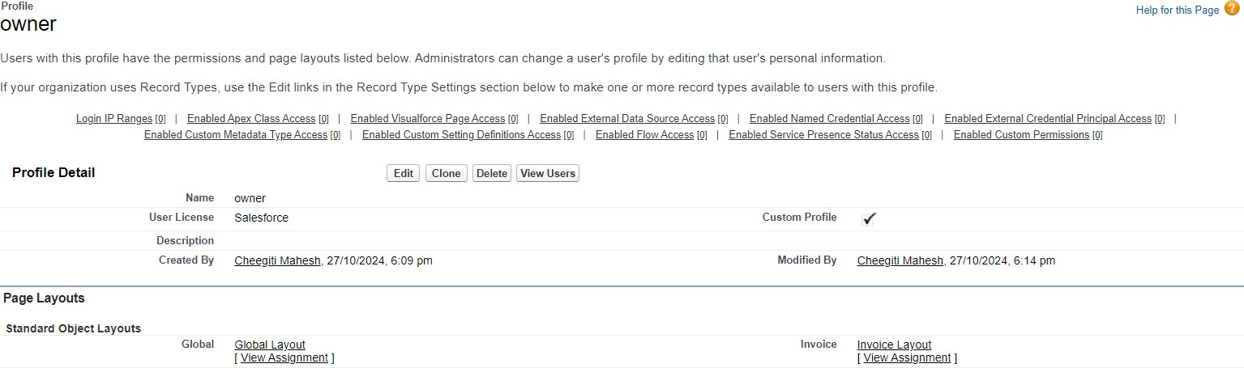

**Agent:**

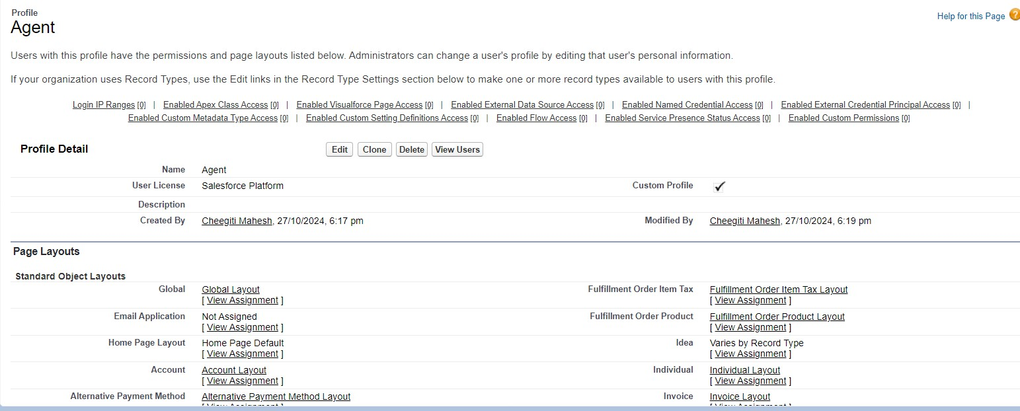

**Step 5: Creating the Roles in Roles Heirarchy**

The created Owner Role and the Agent Role are included in the Role heirarchy. Ownerrole is placedunder the CEO Role and Agent Role under the Owner Role.

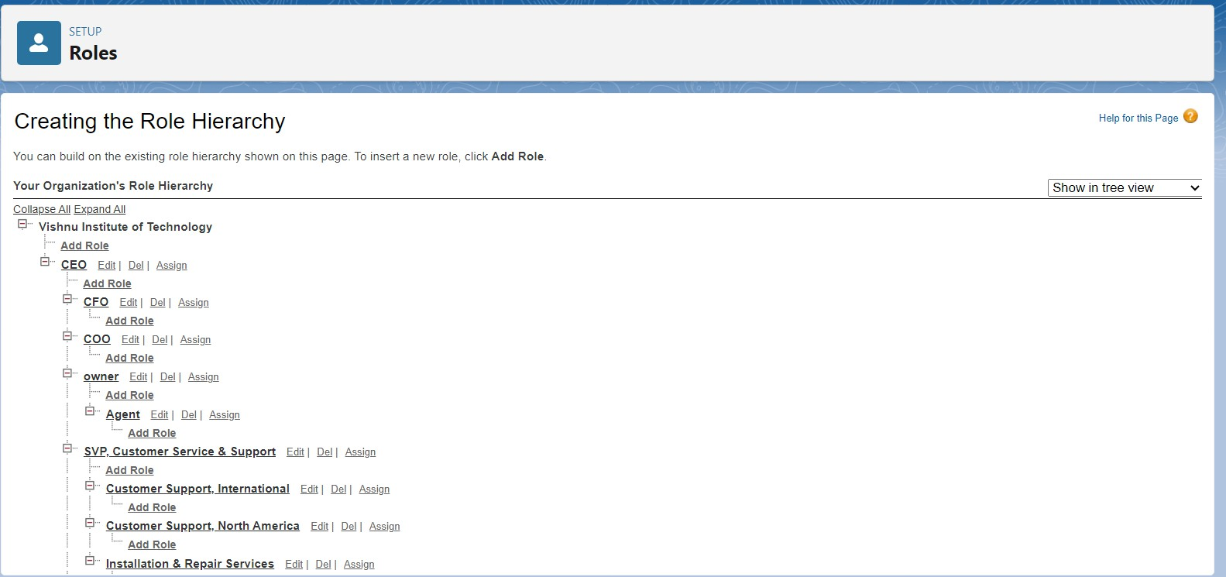

## Step - 6: Flows

Created a Record-triggered flow to automatethe laptop bookingprocess that is initiated by the cosumer.This flow automateswhat to do after bookingthe laptop like triggering email notifications.



## Step - 6: Apex Programming Apex Classes:

**LaptopBookingHandler.apxc:**

The LaptopBookingHandler class’ssendEmailNotification method sends a welcome email to customers in the Laptop_Bookings c list. It customizes the email body with details like the customer’s name, laptop amount, core type, and model, then sends it using Messaging.SingleEmailMessage

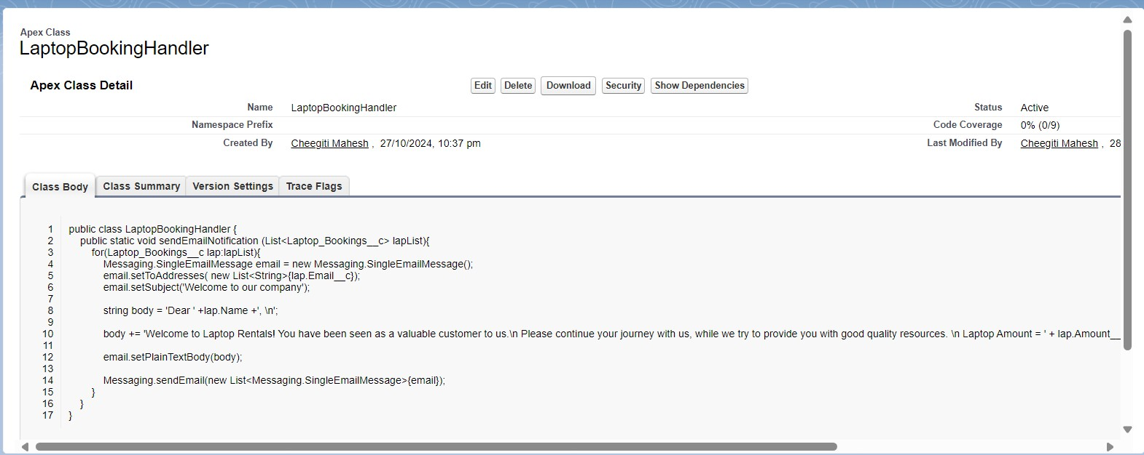

## LaptopHandlerTest.apxc:

This test class, LaptopBookingHandlerTest, verifies the sendEmailNotification method in LaptopBookingHandler. It starts by creating a test consumer and a laptop inventory record. Then, it adds a sample booking in the Laptop_Bookings c list, linking it to the consumer’s emailand specifying detailslike laptop model and rentalperiod.

Using Test.startTest() and Test.stopTest(), it executes the sendEmailNotification method and checks if emails were sent by asserting the Limits.getEmailInvocations() count, ensuringthe method behavesas expected.

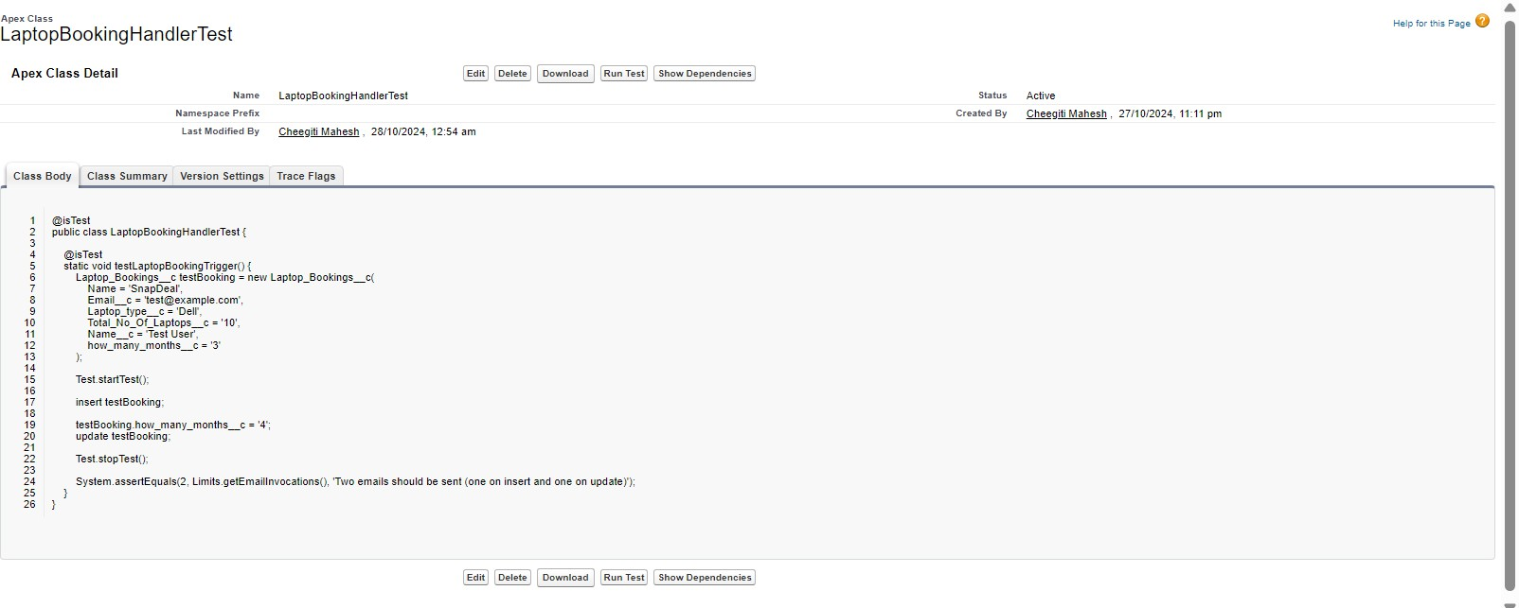

## Apex Trigger:

**LaptopBooking.apxt:**

This trigger, LaptopBooking, runs on the Laptop_Bookings c object after records are inserted or updated. When triggered, it checks if the operation is an after insert or after update and then calls the sendEmailNotification method from LaptopBookingHandler, passing in the newly inserted or updated records.This ensures that customers receivea notification email whenever a new bookingis created or an existingone is updated.

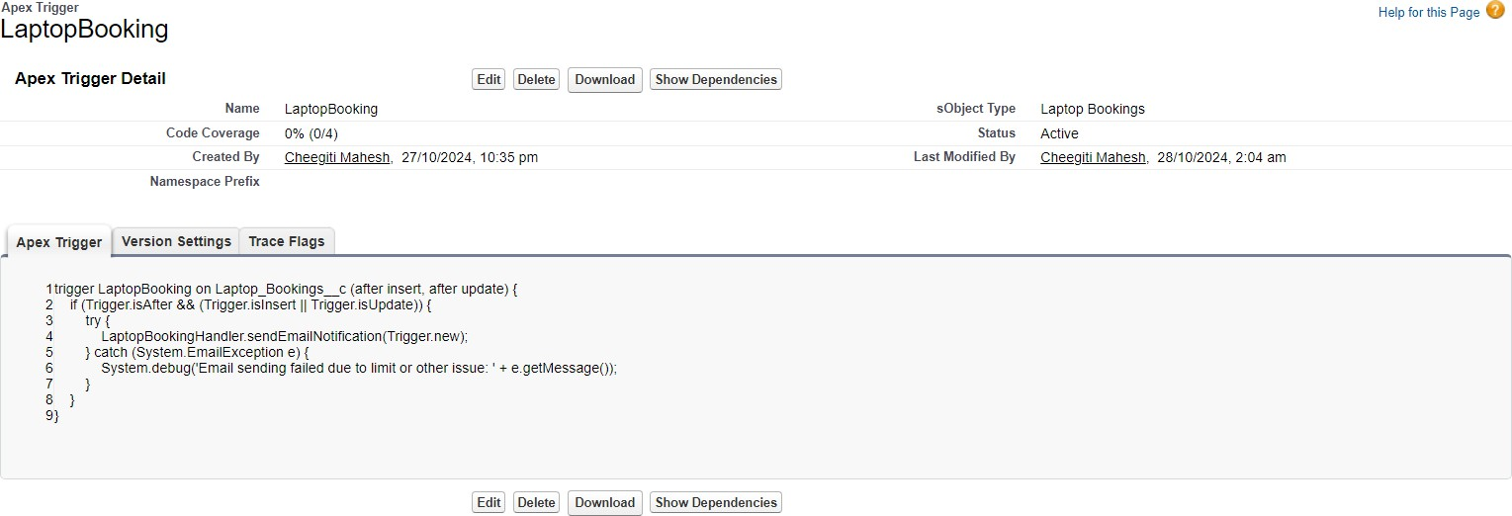

## Step - 7:Creating Report

A report was created based on **Laptop Bookings**, organizing rental data into **buckets** according to the Amountc field. The bookings are categorized into **Basic**,**Intermediate**, **High**, and **Very High** tiers, providing an easy-to-read summary of booking distributions across different price ranges. This setup enablesquick insights into customer preferences for various pricing levels, helping to analyze rental demand and optimizeinventory management accordingly.

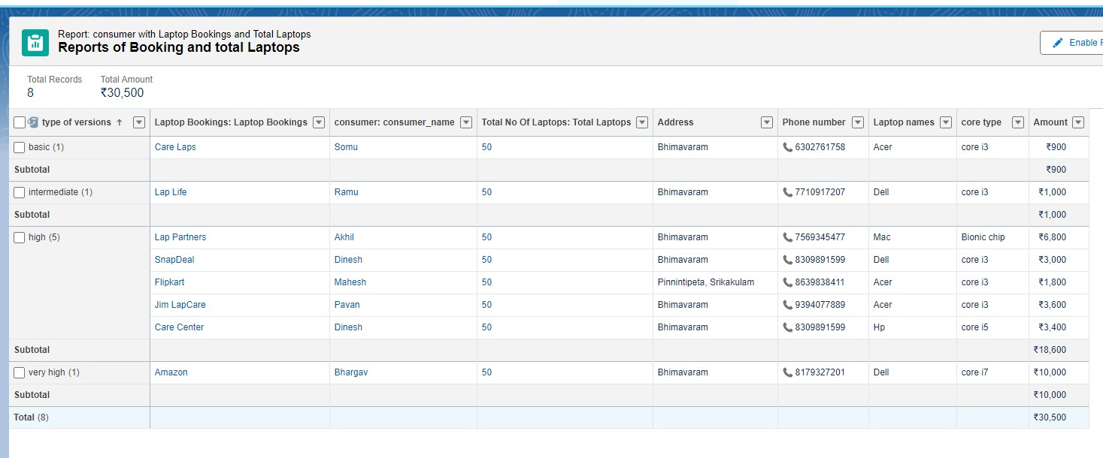

## Step - 8: Creating a dashboard

A **donut chart and some more charts** were added to the dashboard to visually represent the **Laptop Bookings** report, segmented by the pricing buckets—**Basic**, **Intermediate**, **High**, and **Very High**. This chart provides an at-a-glance view of the distribution of bookings across differentprice tiers, making it easier to understand customer demand patterns and quickly assess which laptop rentaloptions are most popular.

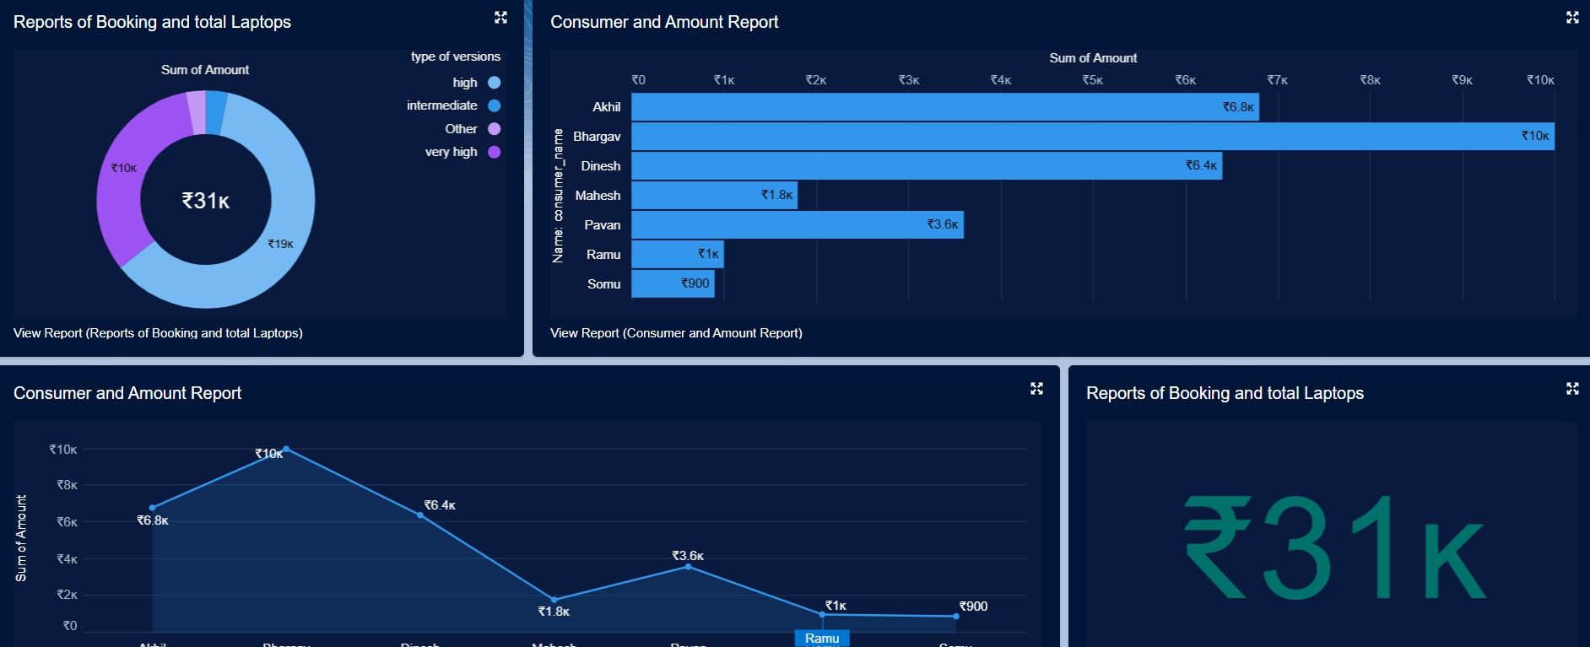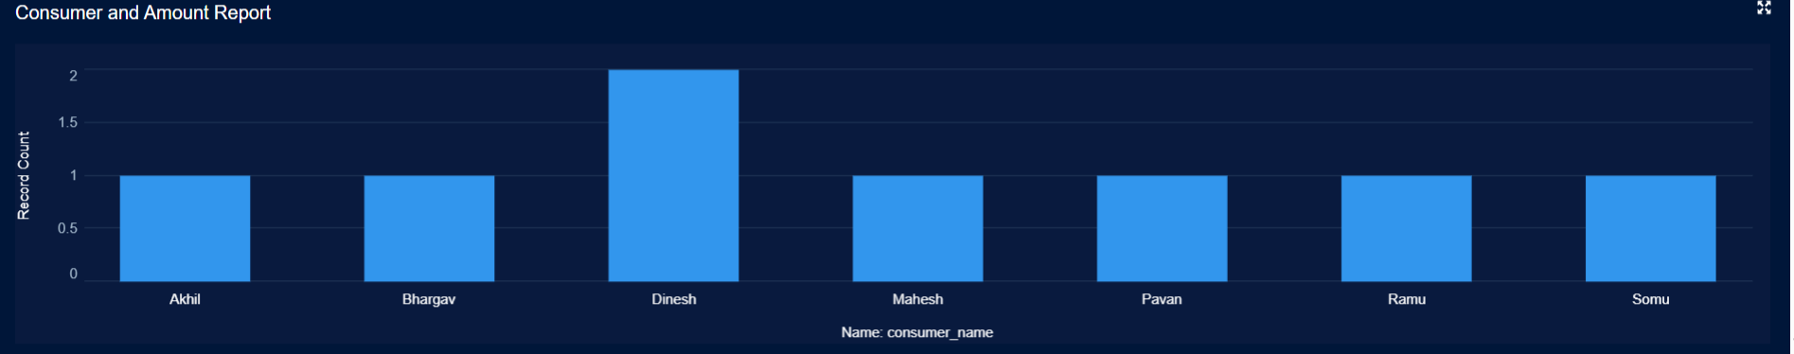

# Testing and Validation

To ensure the application performsas expected, varioustesting approaches were applied:

* + **Unit Testing:** All Apex classes and triggers were tested with unit tests, achieving at 100% code coverage.
  + **User Interface Testing:**UI elements such as the flow of booking laptops,navigation between tabs, and form validations were tested manually and via testscripts.

# Key Scenarios Addressed by Salesforce in the Implementation Project

* + **Eﬃcient Customer Management**: Salesforce captures and organizes customer data, allowingfor streamlined management and quick access to customerdetails, contact information, and booking history.
  + **Automated Rental Booking Process**: By using customobjects and workflows,the system automates the booking process, including tracking available laptops and ensuring up-to-date inventory status.
  + **Seamless Billing and Invoicing**: Automated billing functionality through Apex triggersand workflows ensuresaccurate billing for each rental, with invoice details readily accessible for both customersand staff.
  + **Enhanced Customer Communication**: Salesforce enables personalized, automated email notifications, keeping customers informed at each stage of their rentalexperience—from booking confirmation to reminders.

# Conclusion

In conclusion, the **Laptop Rentals CRM** implementation exemplifies a transformative approach to customer relationship management, seamlessly integrating automation, personalized communication, and insightful analytics. This solution not only enhancesoperational efficiency but also elevates the customer experience, positioning the business for sustained growth and success in the competitive rentalmarket.

**CHEKURI LIKITH VISHNU INSTITUTE OF TECHNOLOGY**